1. INTRODUCTION

Welcome! Ionic is a powerful HTML5 SDK that helps you build native-feeling mobile apps using web technologies like HTML, CSS, and Javascript.
Ionic is focused mainly on the look and feel, and UI interaction of your app. That means we aren't a replacement for PhoneGap or your favorite Javascript framework. Instead, Ionic simply fits in well with these projects in order to simplify one big part of your app: the front end. We recommend reading Where does the Ionic Framework fit in? to get a good understanding of Ionic's goals.
Ionic currently requires AngularJS in order to work at its full potential. While you can still use the CSS portion of the framework, you'll miss out on powerful UI interactions, gestures, animations, and other things.
We will be releasing Cordova/PhoneGap plugins in the future to expand the capabilities of your apps.
Ionic Framework is an open source UI toolkit for building performant, high-quality mobile and desktop apps using web technologies (HTML, CSS, and JavaScript).
Ionic Framework is focused on the frontend user experience, or UI interaction of an app (controls, interactions, gestures, animations). It’s easy to learn, and integrates nicely with other libraries or frameworks, such as Angular, or can be used standalone without a frontend framework using a simple script include.
Currently, Ionic Framework has official integration with Angular, but support for Vue and React are in development. If you’d like to learn more about Ionic Framework before diving in, we created a video to walk you through the basics.
It provides simple, easy to understand explanations with useful working examples. We will go through most of the Ionic Framework so you can also use this as a reference for your projects. This tutorial is intended to make you comfortable in getting started with the Ionic Open Source Framework and its various functions.
Since Ionic is built on top of AngularJS and Apache Cordova, you will need to have basic knowledge about these technologies. You also need to be familiar with HTML, CSS and JavaScript, if you want to understand all the information provided.

2. Ionic CSS Components

2.1 Ionic – Content

Almost every mobile app contains some fundamental elements. Usually those elements include a header and a footer that will cover the top and the bottom part of the screen. All the other elements will be placed between these two. Ionic provides ion-content element that serves as a container that will wrap all the other elements that we want to create.
This container has some unique characteristics, but since this is a JavaScript based component which we will cover in the later part of this tutorial.
<div class = "bar bar-header">
<h1 class = "title">Header</h1>
</div>

<div class = "list">
<label class = "item item-input">
<input type = "text" placeholder = "Placeholder 1" />
</label>

<label class = "item item-input">
<input type = "text" placeholder = "Placeholder 2" />
</label>
</div>

<div class = "bar bar-footer">
<h1 class = "title">Footer</h1>
</div>

2.2 Adding Header

The Ionic header bar is located on top of the screen. It can contain title, icons, buttons or some other elements on top of it. There are predefined classes of headers that you can use. You can check all of it in this tutorial.
The main class for all the bars you might use in your app is bar. This class will always be applied to all the bars in your app. All bar subclasses will use the prefix – bar.
If you want to create a header, you need to add bar-header after your main bar class. Open your www/index.html file and add the header class inside your body tag. We are adding a header to the index.html body because we want it to be available on every screen in the app.
Since bar-header class has default (white) styling applied, we will add the title on top of it, so you can differentiate it from the rest of your screen.
<div class = "bar bar-header">
<h1 class = "title">Header</h1>
</div>
The above code will produce the following screen −


Header Colors
If you want to style your header, you just need to add the appropriate color class to it. When you style your elements, you need to add your main element class as prefix to your color class. Since we are styling the header bar, the prefix class will be bar and the color class that we want to use in this example is positive (blue).
<div class = "bar bar-header bar-positive">
<h1 class = "title">Header</h1>
</div>
The above code will produce the following screen −

You can use any of the following nine classes to give a color of your choice to your app header −
Color Class | Description | Result
bar-light | To be used for white color
bar-stable | To be used for light grey color
bar-positive | To be used for blue color
bar-calm | To be used for light blue color
bar-balanced | To be used for green color
bar-energized | To be used for yellow color
bar-assertive | To be used for red color
bar-royal | To be used for violet color
bar-dark | To be used for black color

Header Elements
We can add other elements inside the header. The following code is an example to add a menu button and a home button inside a header. We will also add icons on top of our header buttons.
<div class = "bar bar-header bar-positive">
<button class = "button icon ion-navicon"></button>
<h1 class = "title">Header Buttons</h1>
<button class = "button icon ion-home"></button>
</div>
The above code will produce the following screen −


Sub Header
You can create a sub header that will be located just below the header bar. The following example will show how to add a header and a sub header to your app. Here, we have styled the sub header with an "assertive" (red) color class.
<div class = "bar bar-header bar-positive">
<button class = "button icon ion-navicon"></button>
<h1 class = "title">Header Buttons</h1>
<button class = "button icon ion-home"></button>
</div><div class = "bar bar-subheader bar-assertive">
<h2 class = "title">Sub Header</h2>
</div>

The above code will produce the following screen −

When your route is changed to any of the app screens, you will notice that the header and the sub header are covering some content as shown in the screenshot below.

To fix this you need to add a ‘has-header’ or a ‘has-subheader’ class to the ion-content tags of your screens. Open one of your HTML files from www/templates and add the has-subheader class to the ion-content. If you only use header in your app, you will need to add the has-header class instead.
<ion-content class = "padding has-subheader">
The above code will produce the following screen −
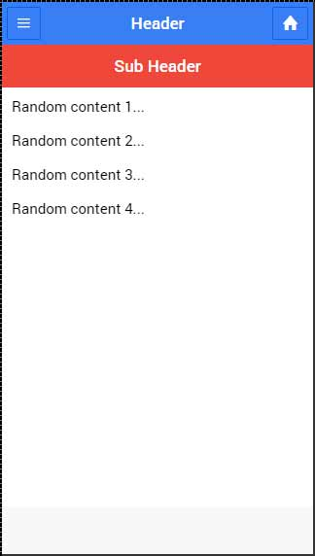

3. Ionic JavaScript Components

3.1 Ionic - JavaScript Content
Almost every mobile app contains some fundamental elements. Usually these elements include a header and a footer, which will cover the top and the bottom part of the screen. All the other elements will be placed between these two. Ionic provide ion-content element that serves as a container, which will wrap all the other elements that we want to create.
Let us consider the following example −
<div class = "bar bar-header">
<h1 class = "title">Header</h1>
</div>

<div class = "list">
<label class = "item item-input">
<input type = "text" placeholder = "Placeholder 1" />
</label>

<label class = "item item-input">
<input type = "text" placeholder = "Placeholder 2" />
</label>
</div>

<div class = "bar bar-footer">
<h1 class = "title">Footer</h1>
</div>

3.2 Ionic - JavaScript Forms
In this chapter, we will understand what JavaScript forms are and will learn what a JavaScript checkbox, radio buttons and toggle are.

Using ion-checkbox
Let us see how to use the Ionic JavaScript checkbox. Firstly, we need to create an ion-checkbox element in the HTML file. Inside this, we will assign an ng-model attribute that will be connected to the angular $scope. You will notice that we are using a dot when defining the value of a model even though it would work without it. This will allow us to keep the link between the child and the parent scopes at all times.
This is very important as it helps to avoid some issues that could happen in the future. After we create the element, we will bind its value using angular expressions.
<ion-checkbox ng-model = "checkboxModel.value1">Checkbox 1</ion-checkbox>
<ion-checkbox ng-model = "checkboxModel.value2">Checkbox 2</ion-checkbox>

<p>Checkbox 1 value is: <b>{{checkboxModel.value1}}</b></p>
<p>Checkbox 2 value is: <b>{{checkboxModel.value2}}</b></p>
Next, we need to assign values to our model inside the controller. The values we will use are false, since we want to start with unchecked checkboxes.
$scope.checkboxModel = {
value1 : false,
value2 : false
};
The above code will produce the following screen −

Now, when we tap the checkbox elements, it will automatically change their model value to “true” as shown in the following screenshot.


Using ion-radio
To start with, we should create three ion-radio elements in our HTML and assign the ng-model and the ng-value to it. After that, we will display the chosen value with angular expression. We will start by unchecking all the three radioelements, so the value will not be assigned to our screen.
<ion-radio ng-model = "radioModel.value" ng-value = "1">Radio 1</ion-radio>
<ion-radio ng-model = "radioModel.value" ng-value = "2">Radio 2</ion-radio>
<ion-radio ng-model = "radioModel.value" ng-value = "3">Radio 3</ion-radio>

<p>Radio value is: <b>{{radioModel.value}}</b></p>
The above code will produce the following screen −
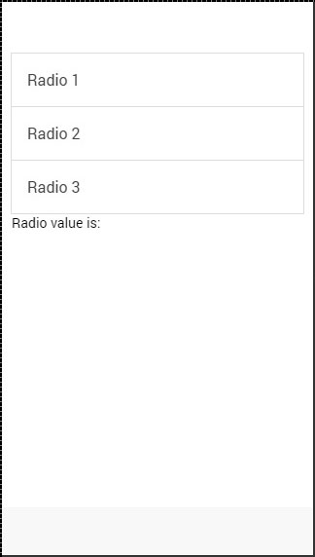
When we tap on the second checkbox element, the value will change accordingly.
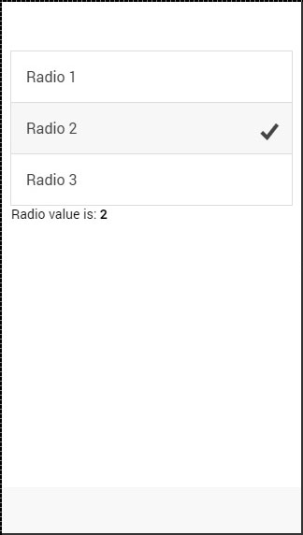

Using ion-toggle
You will notice that toggle is similar to checkbox. We will follow the same steps as we did with our checkbox. In the HTML file, first we will create ion-toggleelements, then assign the ng-model value and then bind expression values of to our view.
<ion-toggle ng-model = "toggleModel.value1">Toggle 1</ion-toggle>
<ion-toggle ng-model = "toggleModel.value2">Toggle 2</ion-toggle>
<ion-toggle ng-model = "toggleModel.value3">Toggle 3</ion-toggle>

<p>Toggle value 1 is: <b>{{toggleModel.value1}}</b></p>
<p>Toggle value 2 is: <b>{{toggleModel.value2}}</b></p>
<p>Toggle value 3 is: <b>{{toggleModel.value3}}</b></p>
Next, we will assign values to $scope.toggleModel in our controller. Since, toggle uses Boolean values, we will assign true to the first element and falseto the other two.
$scope.toggleModel = {
value1 : true,
value2 : false,
value3 : false
};
The above code will produce the following screen −

Now we will tap on second and third toggle to show you how the values change from false to true.


4. IMPLEMENTATION OR ADVANTAGES AND DISADVANTAGES

4.1 ADVANTAGE
Easy to learn: If you have familiarity with html, css and JavaScript you can learn it very fast
Easy documentation: Ionic has very good and well documentation. Most of the things are covered in their official site. So you don’t have to move around different sites to learn.
Rapid development: By running some command line commands, you can create pages (e.g. ionic g page your_ page_ name), providers etc. When you run a command it generates all files with template codes. So you don’t have to write everything from scratch.
Ionic apps run on different platforms.g. Android, iOS, windows etc. As a result you don’t have to write codes for each platform. It reduces development time a lot.
Develop an app once, and deploy across iOS, Android, and Windows devices.
Framework’s focus on HTML, CSS, and JS enables quick development, low costs, and minimal maintenance.
Default User Interface: It has many default CSS and JS components that cover most of the essential/basic things which you want to create into a mobile application. Apart from regular ones like buttons and navigation it also includes form inputs, lists, cards, sliding boxes and many more. These can be easily customized by adding CSS classes to the element.
Feasible Cross Mobile App Development : Developing an application at once is very essential as it would be compatible with all the mobile devices. However, it needs extremely limited use of time, assets and efforts, and helps in giving a unified look and feel. Beside, Ionic assists in building applications rapidly with expertise, and deploys standard tools with a single code base.
Built On AngularJS : If you’ve worked upon Ionic, then you would likely realize that it is developed on top of the Angular JS framework. Furthermore, Ionic framework shares compatibility with AngularJS, thus, the benefits of Angular JS development can be put to use too.
Ionic framework is excellent for quick application ideas prototyping.
Development cost is less compared to native iOS and Android applications.

4.2 DISADVANTAGES
Performance: Native mobile application’s performance is better than ionic app. However, in most of the cases, performance gap is not noticeable.
Security: If you are developing financial app e.g. app for bank, ionic framework is not recommended. It may not provide as much security as native application.
Limited native functionality: There may be some native functions that may be not available in ionic framework. In that case you have to develop the plugin yourself. However, there are many plugins available to cover native functionalities.
Building in-app navigation can be notably complex, as the ui-router is tricky to maneuver at present.
It is not suited for high-end graphics dependent applications or games.
Performances are not as good as native applications, namely animations, scrolling, and network operations.
As mentioned, JavaScript animations are not as performant as native animations. However, there are JavaScript libraries, like tweenMAX, which provide decent animation performance on the devices.
Possible performance issues depending on application type. But alternatives to Phone Gap do exist.
Need for specialists. JS can be tricky to learn. And you'll need someone who can not only "do" JS, but also have deep knowledge of a handful of advanced libraries and technologies including Angular, Cordova, Ionic, etc.
Early adopter risk. This technology is still in its infancy. Support keeps changing, standards keep changing, and libraries can be completely rewritten at any time.

4.3 IMPLEMENTATION
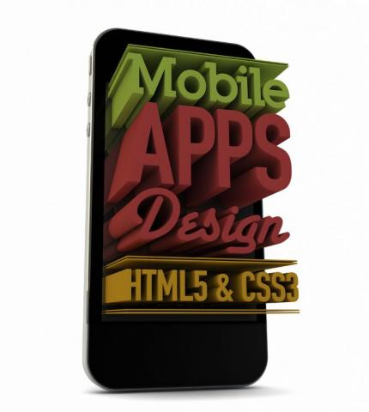
Before starting with the introduction of the Ionic framework, I would like to discuss the powers of HTML, CSS and JavaScript. Using these technologies, a UI Developer can create UI for cloud based applications, web applications, parallax websites, and much more.
The technology has now come so far that you can create mobile applications using HTML, CSS, and JavaScript. You must be thinking, how? Yes, this blog is all about creating a mobile application using HTML, CSS and JavaScript. After reading this blog, you will be able to start creating mobile application UI using HTML5 web technology.
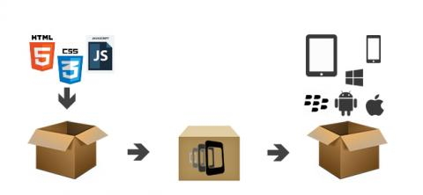
Figure 1: The process of creating a hybrid mobile app using web technology
These are the 3 steps that a UI Developer must know:
Creating pages in HTML/HTML5, CSS/CSS3/SASS and JavaScript/JQuery for mobile.
Converting code into Native Installer using Phonegap
Installing the built-in APK in android and IPA for IPhone
We know about Bootstrap; it is a HTML, CSS, and JavaScript framework that creates responsive mobile-first designs and beautiful UI structures for web sites or web applications. Similarly, there are other frameworks available to create hybrid mobile applications using HTML, CSS, and JavaScript.
The Top Hybrid Mobile App Development Frameworks include:
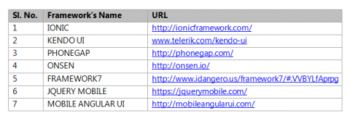
An Introduction to the Ionic Framework
Ionic is one of the most promising HTML 5 mobile application frameworks. Built using SASS, it provides many UI components to help develop rich and interactive apps. It uses the JavaScript MVVM framework, and Angular JS to power apps.
Ionic Installation Steps
Step 1: Install Ionic
In this step, you install the Ionic Framework and Cordova using npm (the Node Package Manager).
npm install -g cordova ionic
npm install -g cordova ionic
npm install -g cordova ionic
npm install -g cordova ionic
npm install -g cordova ionic
npm install -g cordova ionic
npm install -g cordova ionic
npm install -g cordova ionic
Step 2: Creating an Ionic Application
In this step, you can use the Ionic CLI to create a new application based on the side menu starter app.
ionic start MYAPP sidemenu
cd MYAPP

ionic serve

ionic start MYAPP sidemenu

cd MYAPP

ionic serve

5. CONCLUSION

Ionic framework have their benefits and limitations for android apps. This ionic framework allows for the creation of highly interactive, mobile apps that can be deployed across iOS, Android, and Windows devices.The main Ionic advantages surround the simplicity that comes with developing an app once, rather than multiple times for separate devices.
The ionic framework is very easy to learn for us. It is not too difficult for learning or knowing about this framework.It has many default CSS and JS components that cover most of the essential/basic things which you want to create into a mobile application.
The Ionic Framework is a web-based technology used for mobile app development - a crucial missing piece for UI developers until now. This framework is designed to quickly get up to speed in developing native applications for multiple devices using HTML5, CSS and JavaScript.Based on my experience, I believe that it is one of the best options for hybrid app development among other frameworks available on the web. Finally, it’s the developer’s choice concerning which framework he/she wants to use for their APP development.

6. REFERENCES

  - TEXT REFERENCE

[1] Mobile App Development with Ionic, Revised Edition: Cross-Platform Apps with Ionic, Angular, and Cordova

[2] Ionic in Action: Hybrid Mobile Apps with Ionic and AngularJS

  - WEB REFERENCE

[1] https://ionicframework.com/docs/v1/overview/#license.

[2] https://tvsnext.io/blog/advantages-of-ionic-framework-app-development/

[3] https://www.hcltech.com/blogs/ionic-framework-hybrid-mobile-applications

